**Project Design Phase-II Data Flow Diagram & User Stories**

**Example:**

**(**

**Simplified**

**)**

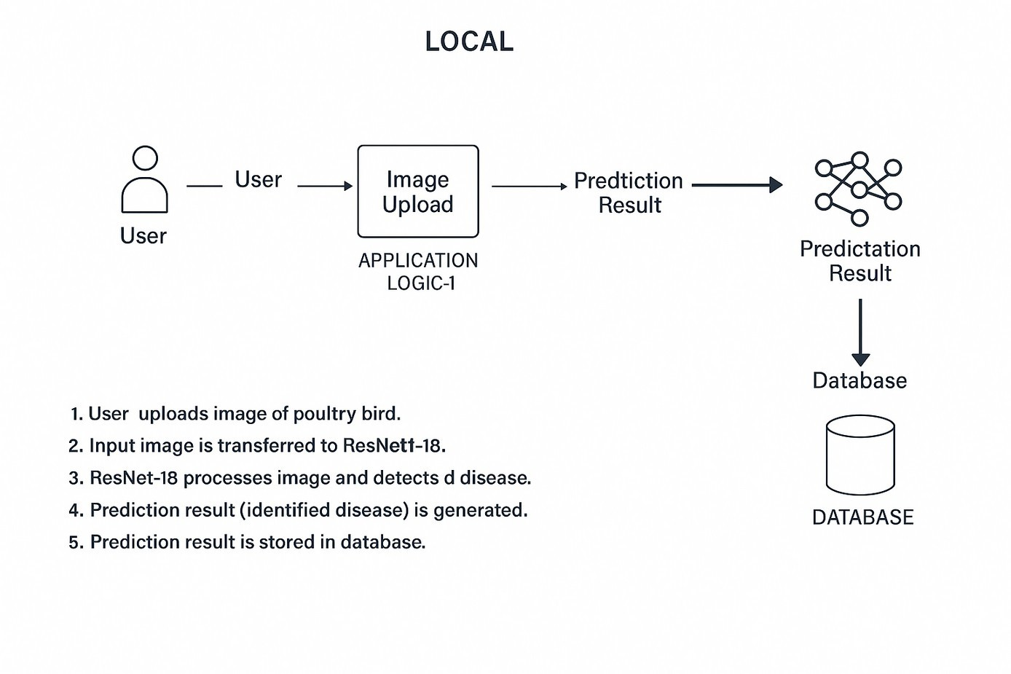

User uploads image of Blood

cell then it is transferred to

MobileNetV2.It processes image

and detects the type of blood

cell.Prediction result(identified

type) is generated.

and stored in database.

|  |  |
| --- | --- |
| Date | 26 June 2025 |
| Team ID | LTVIP2025TMID39268 |
| Project Name | Hematovision – Advanced Blood Cell  Classification using Transfer Learning |
| Maximum Marks | 4 Marks |

**Data Flow Diagrams:**

A Data Flow Diagram (DFD) is a traditional visual representation of the information flows within a system. A neat and clear DFD can depict the right amount of the system requirement graphically. It shows how data enters and leaves the system, what changes the information, and where data is stored.

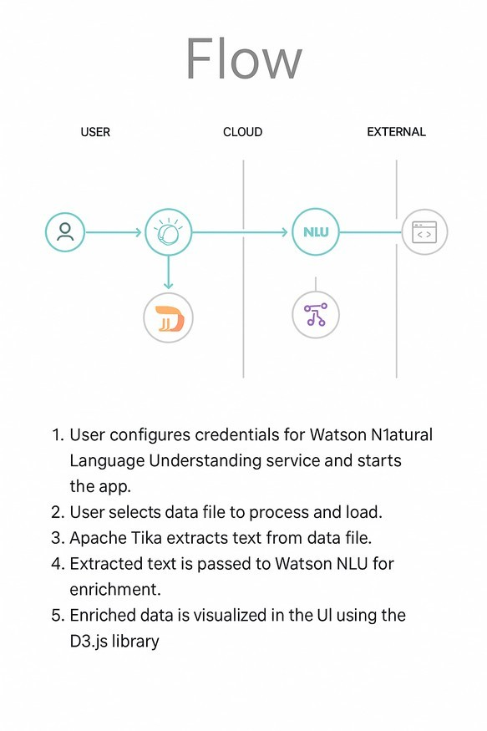

Example: DFD Level 0 (Industry Standard)

**User Stories**

Use the below template to list all the user stories for the product.

|  |  |  |  |  |  |  |
| --- | --- | --- | --- | --- | --- | --- |
| **User Type** | **Functional**  **Requirement**  **(Epic)** | **User Story**  **Number** | **User Story / Task** | **Acceptance criteria** | **Priority** | **Release** |
| Customer (Web user) | Image Upload | USN-1 | As a user, I can upload a Blood Cell image from my system. | Image file (JPG/PNG) is accepted and previewed. | High | Sprint-1 |
|  | Image Upload | USN-2 | As a user, I receive an error if I upload an invalid file. | Invalid file types are rejected with a message. | Medium | Sprint-1 |
|  | Blood Cell Type Detection | USN-3 | As a user, I can get a prediction for uploaded image. | Model output is shown with confidence score. | Higj | Sprint-2 |
|  | Prediction Result Display | USN-4 | As a user, I can view the Blood cell type and confidence level. | Blood Cell type and percentage is displayed. | High | Sprint-2 |
|  | History Tracking  (Optional) | USN-5 | As a user, I can view my previous uploaded images and results. | History is shown in tabular or card form. | Low | Sprint-1 |
| Administrator | Model  Management | USN-6 | As an admin, I can update the model or re-deploy it when a better version is read. | New model file can be uploaded into the system. | Medium | Sprint-2 |
|  | Dataset  Expansion  (Optional) | USN-7 | As an admin, I can add new images to retrain or improve the model. | New image added to training dataset folder. | Low | Sprint-2 |